Standard Operating Procedures: Low Permeability Setup
The setup consists of
- ISCO pump for the confining pressure
- Pore pressure pump
- Two pore pressure transducers, one confining pressure transducer and one temperature sensor.
- A pressure vessel (tested till 10,000psi)
- Sample holder
- Controlling Computer

- Confining pressure can be applied and controlled using the ISCO pump.
- Pore pressure is being applied by the Geotac pump and is being controlled by the computer next to the setup.
For options on setting up the pump connections and other pressure transducers refer to the manual provided with the pump. For the current setup the computer is associated with the 2 pore pressure transducers (upstream and downstream) and a temperature sensor. A separate digitizer is also provided for recording confining pressure and strains.

- Login as Ritu and password-geo3geek
- Click on the desktop icon DigiFlow-GP.
- The software opens up and the window looks like below:

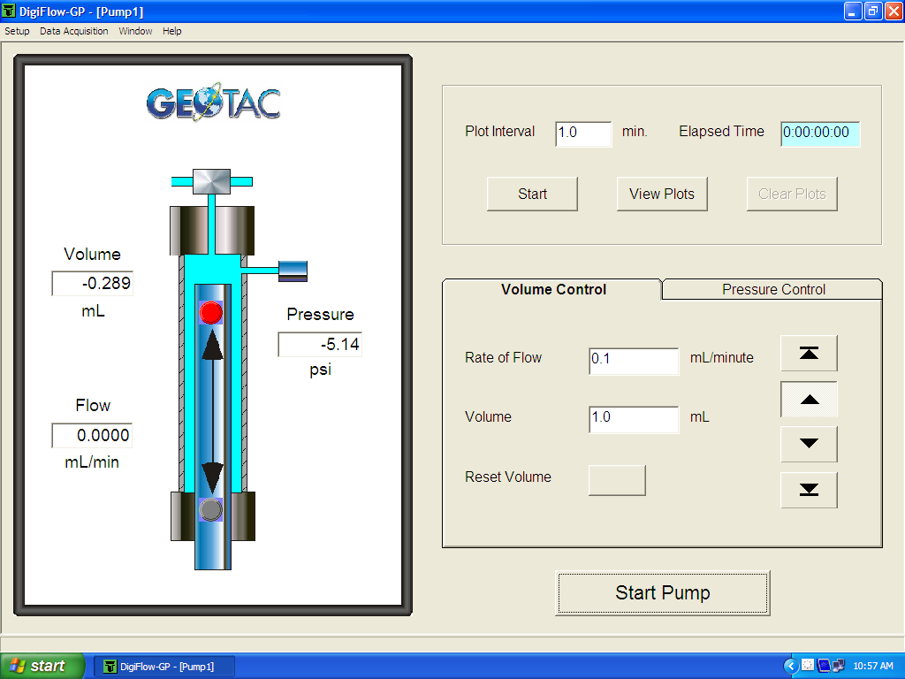
Figure 1: Pore Pressure control window
The pore pressure can be controlled in two ways. One at constant pressure or at constant flow. In figure 1 the two tabs provided on the right hand side of the windows provides us the two options. When the volume control tab is clicked. One can define the flow rate in the space provided (lowest flowrate possible is ~.00005ml/min). Volume can also be mentioned. To flow the pump at that constant flowrate click the single arrow button on the right and click the start pump button at the bottom. Fluids will flow out of the pump at the mentioned flowrate when the valves on the pore pressure lines are open and the valve which connects the fluid reservoir with the pump is closed. The Maximum pore pressure that the system can take is 5000psi. An automatic control mechanism will shut down the fluid flow once pressure reaches 4900psi.
In order to acquire data click the data acquisition button and select one of the data acquisition formats. I have my default setup at 0.15 seconds this collects data for upstream pressure, downstream pressure, temperature and fluid volume. Attached is a datasheet which shows the data format as data is being collected. I have also provided with the spread sheet a macro named “formatting” which when run will analyze the machine generated data into pressure and flowrates.
In order to fill the pump with pore fluid. Click stop pump button at the bottom of the window and then on Open valve 1 between reservoir and pump, close valve 2 to stop outflow of fluid out of the pump and then click the button and then click the start pump button. A connection to the vacuum pump is also provided along with the pore pressure input lines to the sample inside the pressure vessel.

